Saint Columba Religious Education

Parent/Student Handbook
2024-25

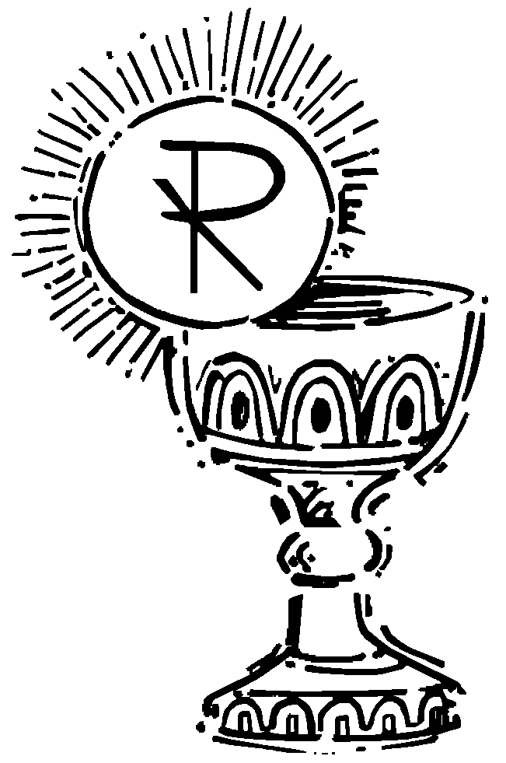

Saint Columba Religious Education Mission Statement

“Our future in faith is to teach our children to know, love and serve God and His people, in the Catholic tradition.”
Table of Contents

Philosophy
Christian Youth Education Goals
Expectations
Relationship between Parents and the Catechetical Program (diocese Policy #1110 RE)
Class Attendance
Cancellations
Baptismal Records
Curriculum
Lost Textbooks
Location of Classes
Health Concerns and Medications
Accidents
Emergencies
Proof of Custody
Special Situations
Prohibited Classroom Activities
Drugs, Alcohol, Smoking & Weapons Policy (#5137, & 5137.5 RE)
Field Trips and Permission Slips #5134.1 RE)
Discipline (#5131 RE)
Harassment (#5136 A & RE)
HIV and AIDS and Related Diseases (#5150 RE)
Homework
Mass Attendance
Registration
Respect
Sacramental Preparation
Special Education
Youth Ministry

Philosophy

The Religious Education Program at Saint Columba Church exists to aid the PARENTS, who are the primary educators in preparing their children to come to full maturity in the Christian life. “The parish is the Eucharistic Community and the heart of the liturgical life of Christian families; it is a privileged place for the catechesis of children and parents (Catechism of the Catholic Church #2223).”
The Religious Education program of Saint Columba Parish follows the guidelines of the Diocese of Harrisburg.

Christian Youth Education Goals

Develop a personal relationship with Jesus
Apply Catholic faith to daily life
Integrate Catholic values
Commit to the Catholic faith for life
Live the moral and theological virtues
Develop Biblical and doctrinal literacy
Develop personal spirituality and prayer life
Participate in the sacraments
Work for justice and defend human dignity
Serve those in need and foster social change
Become healers, reconcilers, and peacemakers
Develop respect for differences
Overcome prejudices
Integrate Catholic sexual values
Develop positive self-image
Utilize the Diocese of Harrisburg Religious Curriculum

Expectations

Student Conduct: (Diocese Policy #5131RE)
Students in the parish religious education programs of the Diocese of Harrisburg are expected to conduct themselves in a manner that reflects favorably on themselves, their families, and their parishes. Students are expected to have respect and to show consideration to the other students in the parish and to the catechetical staff. They are to cooperate to create a harmonious religious education atmosphere.

Students are to recognize their individual responsibilities as a condition for their acceptance into the parish religious education program and their fulfillment of them as a condition for their remaining in any of the parish’s catechetical programs, such as completion of the CYE workbook.

Students are expected to conduct themselves at parish-sponsored activities in a manner that reflects the moral teachings of the Catholic Church. Failure to do this may result in disciplinary action, including expulsion from the parish activity or program.

Relationship between Parents and the Catechetical Program: (Diocese Policy #1110RE)

The Catholic Church continues to teach that parents are the primary educators of their children. Therefore, the parents’/guardians’ role in education and their relationship to the parish catechetical program are to be properly acknowledged and implemented. Mutual respect and cooperation between parents and parish authorities must be developed, especially by means of a well-organized communication network which includes parent/catechist handbooks, newsletters, and parish bulletin announcements.

Class Attendance

Students are expected to attend all classes and to learn the material as presented by their catechist. Classes start at 9:10 AM and finish at 10:15 AM. Students are to be dropped off and picked up in the gymnasium. A yearly schedule is made available to students and parents/guardians.

If a student is absent, the parent/guardian is to send a signed note to the teacher and accept the responsibility to cover the material that was taught during the absence. If your child has missed several classes because of illness or requires additional attention, contact the CYE Coordinator so that the Coordinator can meet with the child’s catechist to get the information needed back to you.

When a student repeatedly misses class, the CYE Coordinator may request a meeting with the student and his/her parents/guardians to decide how this situation can be improved or, if need be, if the student should repeat the grade. It is expected that students come to class respectfully dressed with their religious workbook.

Cancellations

If classes are cancelled due to snow/ice, flooding, etc., parents/guardians can access a recorded message concerning cancellation of class by calling the Parish Office at 784-0801, extension 4.

Baptismal Records

Students new to the CYE program are required to submit a copy of their baptismal certificate before the first class.

Curriculum

The texts used in the CYE program are all approved by the USCCB for content and compliance with the Catechism of the Catholic Church.

Lost Books

There is a replacement fee for a lost workbook.

Location of classes

Classes will be held in the following locations:
Saint Columba School and Parish Center

Health Concerns and Medications

Catechists may not dispense or administer medication to students.
Special needs or conditions (medical or other) should be made known on the Emergency Medical Authorization Form. Confidentiality will be respected. An appointment can be making to personally discuss the situation with the CYE Coordinator.

Accidents

All accidents are to be reported and documented. Report all accidents to the CYE Coordinator as soon as possible.

Emergencies

In case of an emergency we will always try to call the parents first and then refer to the Emergency Medical Authorization form that was filled out at the time of registration.

Proof of Custody

If your child is restricted as to who may pick him/her up after class, please provide a copy of the custody section of the divorce decree to the CYE Coordinator.

Special Situations

If someone other than the person whose name appears on the registration form is picking up your child, we need to be made aware of it in writing.

Prohibited Classroom Activities

Drugs, Alcohol, Smoking & Weapons Policy (#51137 & 5137.5 RE)

Use and /or possession of any illegal drugs, alcohol, cigarettes, weapons (novelty or real) is forbidden. Suspension from the program will result immediately with the length being determined by the CYE Coordinator and Pastor.

Field Trips and Permission Slips (#5134.1 RE)

If an activity or trip is planned, parental/guardian permission slips will be sent home with each child. The student will NOT be allowed to participate in the activity if the official written permission form is not returned. He/she will attend an alternative classroom.

Discipline (#5131 RE)

Religious instruction should be a positive, Christian experience. Students are expected to conduct themselves in a manner that reflects favorably on themselves, their families and their parish. Behavior problems will not be tolerated. The CYE Coordinator will notify parents and a memo will be kept on record. If a conference is necessary it could include the student, parents/guardians CYE Coordinator, teacher and the Pastor. If improper behavior continues, a parent may be required to be present during class time or expulsion from the program may be mandated and home schooling by the parent/guardian will be expected.

Harassment (#5136A and RE)

Any form of harassment (sexual, physical, verbal, etc.) of or by employers, employees, students, or volunteers is prohibited.

HIVAIDS and Related Diseases (#5150 RE)

Parishes cannot prohibit admission to or discriminate against students because of HIV infection, AIDS or related diseases. Parents/guardians are expected to inform the CYE Coordinator if their child has any infectious diseases.

Homework

Please check your child’s folder or papers each week for information or homework that needs to be completed.

Mass Attendance

The Third Commandment and Precept of the Church – Faith formation builds on the family religious experience, which includes weekly attendance at Mass with the parish community. It is your child’s right and duty to participate at Mass. Each child is expected to participate fully at Saint Columba parish by attending Mass regularly.

Registration

The Diocese of Harrisburg requires parents/guardians to complete an Emergency Medical Authorization form every school year in order for a child to be enrolled in the CYE Program. Registration takes place during the months of May and June for the following school year.

Respect (#4107 RE)

Parish employees and volunteers must respect the individual dignity of all students.

Sacrament Preparation (#6003, 6004, and 6005 RE)

The sacraments of Penance and Eucharist are received in the 2nd grade and the Sacrament of Confirmation is received in the 8th grade.
The Diocese of Harrisburg has mandated 2 years of instruction for these sacraments. Regular class and Mass attendance is necessary to be properly prepared. Parental involvement is very important.
Parent meetings are held for helpful guidance and information. At least on parent/guardian is expected to attend. Please refer to the calendar for dates.

Special Education (6002 RE)

The needs of each student must be met and recognized on an individual basis. Parental input is encouraged. Please inform the CYE Coordinator if any disability exists. “The goal is to present Christ’s love and teaching to each person in as full and rich a manner as he/she can assimilate (#195 National Catechetical Directory).”

Youth Ministry

Faith formation does not end with Confirmation in 8th grade but continues on for a lifetime. Youth ministry sessions offer teens of High School age an opportunity to broaden their knowledge, awareness and service in an academic and social setting.

St Columba Junior Catechist Program

Does your High School Student like to work with children?
Do they like to teach or have thought of being a teacher?
Do they love the Catholic Faith?
If this describes your child, they might be perfect for our Junior Catechist Program. Junior Catechists help our Teachers with the Sunday morning CYE classes.

Religious Education
For more information
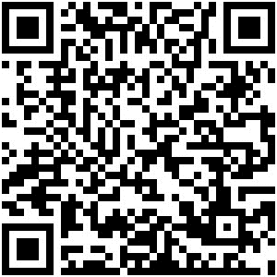
Religious Education – St. Columba Catholic Church (saintcolumbachurch.org)

