Prayer References

Psalms: Especially those of Thanksgiving, Praise
Liturgy of Hours (Shorter Book of Christian Prayer) Divine Office – Liturgy of the Hours of the Roman Catholic Church (Breviary)
Rosary: How to Pray the Rosary | USCCB
Lectio Divina https://hallow.com/blog/how-to-pray-lectio-divina/
How to Pray Lectio Divina – Hallow: Catholic Prayer App
(Read, Meditate, Pray ,Contemplate) with the Scripture
Lectio Musica https://lectiomusica.com/ (Same as LD with Sacred Music Hear M,P,C)
Via Pulchritudinis http://www.theologia.va/content/cultura/en/pub/documenti/ViaPulchritudinis.html (Same as LD with Sacred Art See, M,P,C) The Via Pulchritudinis, Way of Beauty (theologia.va)
Examen of St Ignatius of Loyola https://www.ignatianspirituality.com/ignatian-prayer/the-examen/ The Daily Examen - IgnatianSpirituality.com
General http://www.4catholiceducators.com/prayer2.htm
Writing a Family Prayer
- Write from your Heart
- Everyone in the family contributes something
- Areas to concentrate on
  - Thanksgiving- Give Thanks to God for something
  - Acknowledge your need of God
  - Pray for Others – The Body of Christ
  - Pray for your needs by the will of God
  - Thank God for your Family
- Decide when to Pray as a Family
Our Family Prayer:

____________________________________________________________________________________________________________________________________________________________________________________________________________________________________________________________________________________________________________________________________________________________________________________________________________________________________________________________________________________

FORMED.org
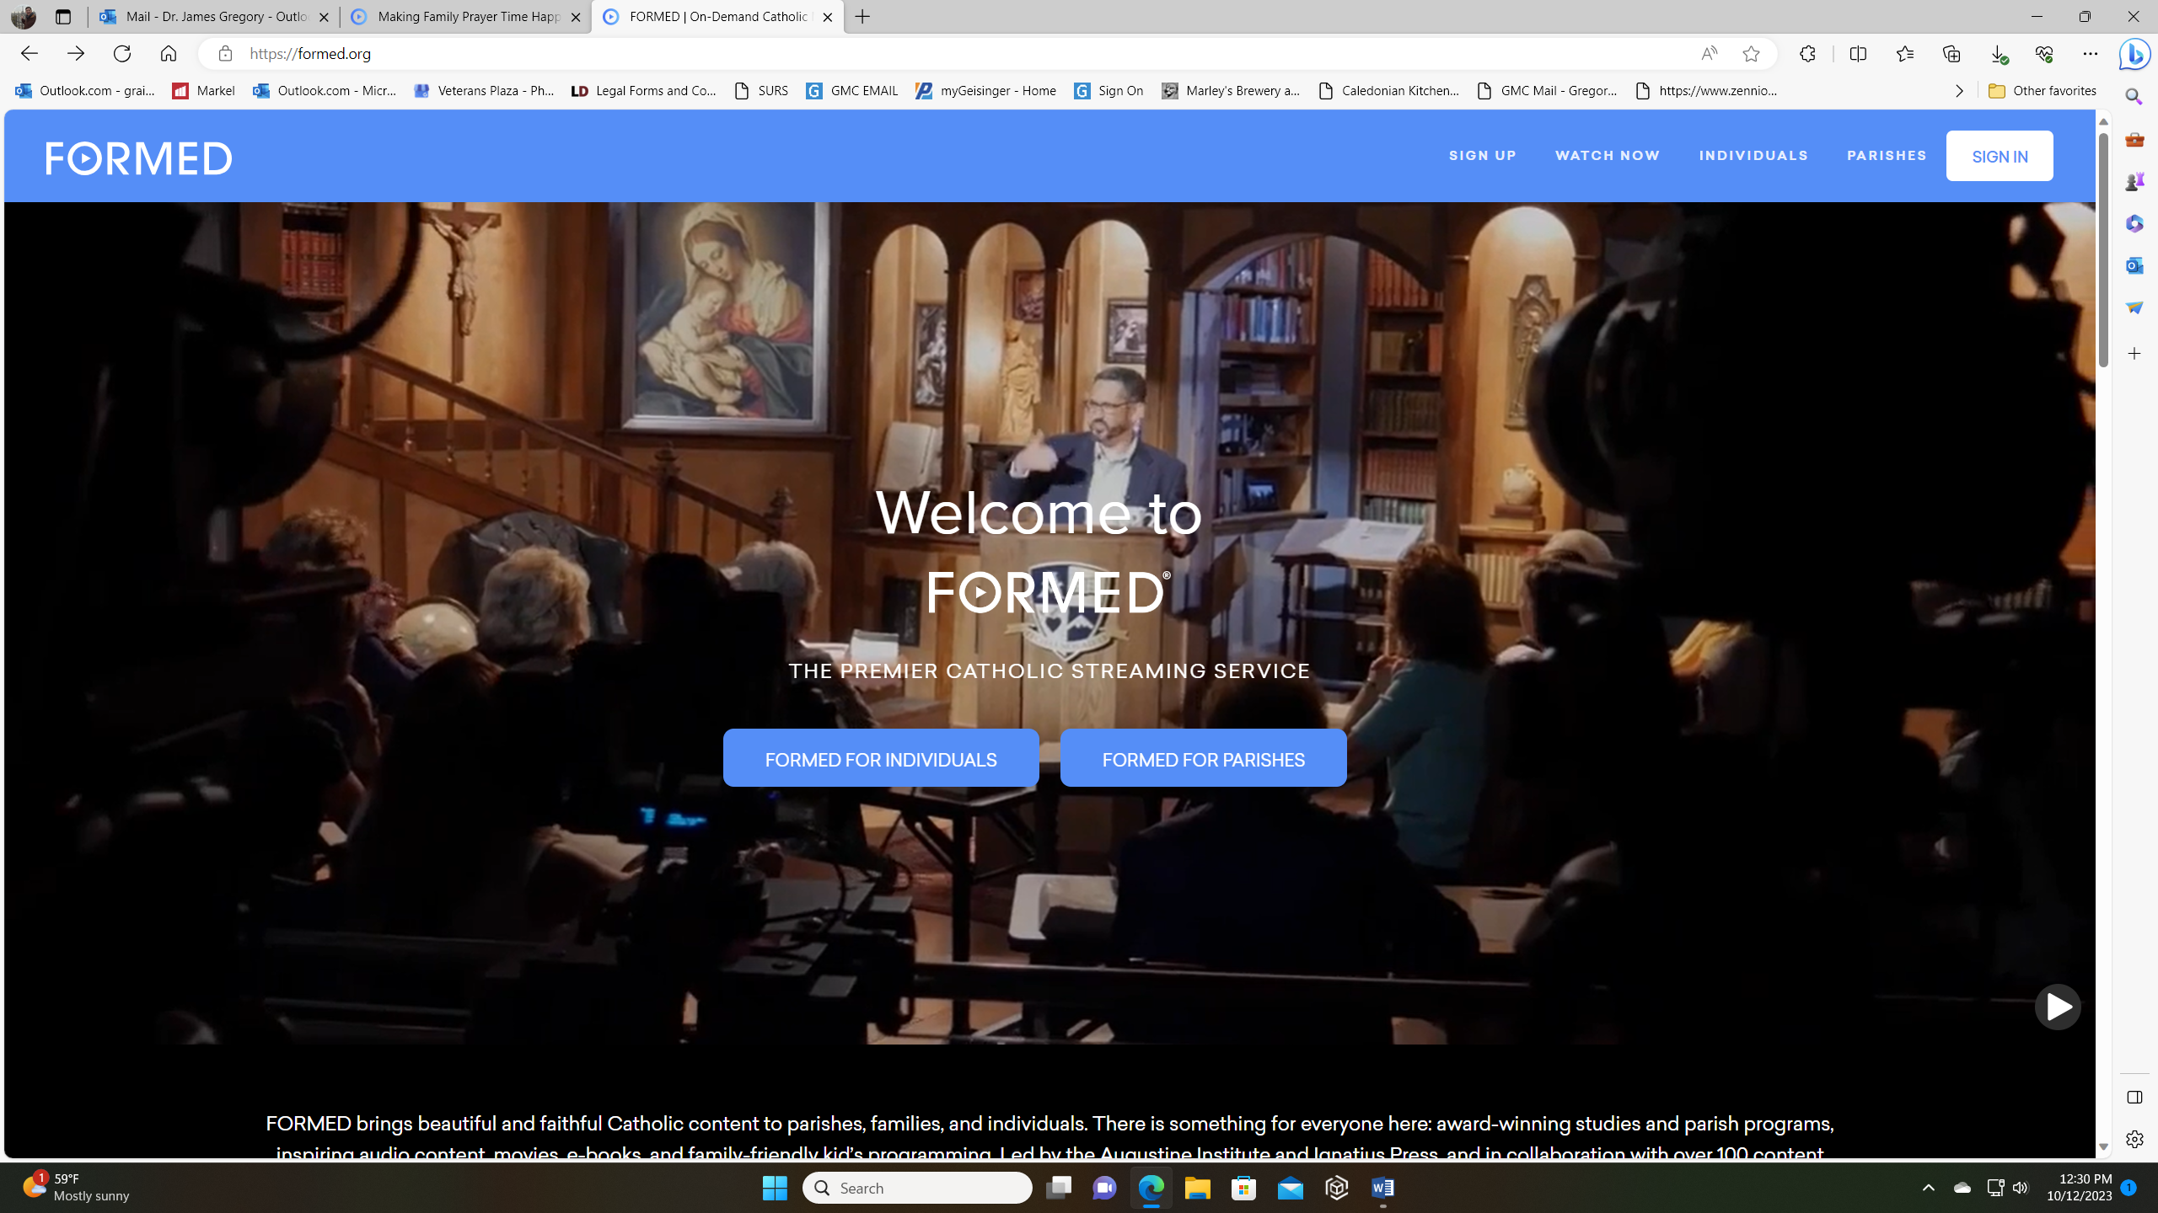
Go to Red Sign UP NOT Sign in Click and put in the Zip of the Church 17815
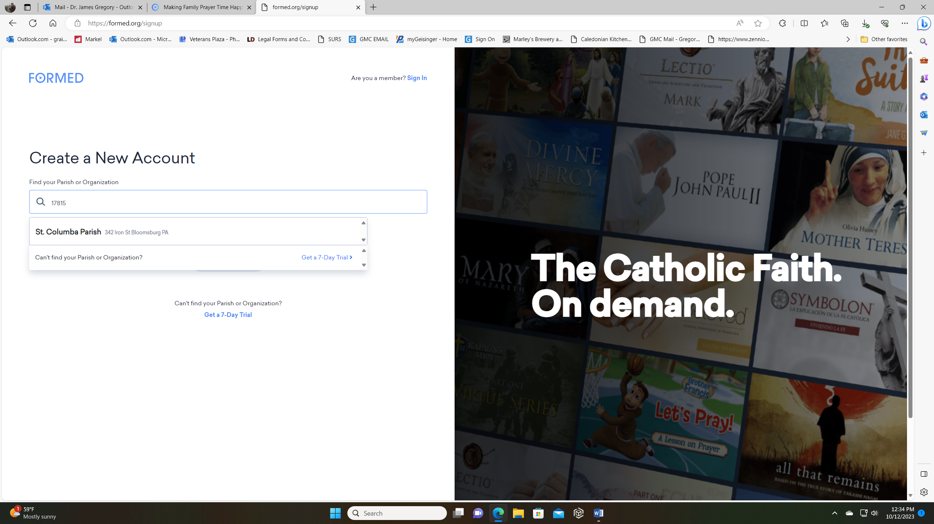
Choose St Columba and then follow the instructions. YOU only need do this once then each time it will log you on

