Dear Parents,

SAVE THE DATE:
CYE Parents Meeting
Sunday August 27th
09:10-10:30
School Gymnasium
(Immediately after the 8AM Mass)
This required meeting for ALL parents of children in our CYE programs will kick off the 2023-24 Sunday School year. We will discuss the changes to the program especially the Central Role Parents have in the education of their children. I will introduce new resources that the Office of Religious Education will provide parents and explain the Four New Family catechesis days.
Those of you who have not completed your 2023-24 can do so by:
- Completing the on-line registration and emailing it back to me (see link)
- Completing registration, the day of the Parents meeting.
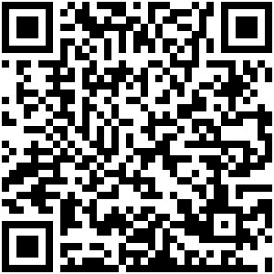
Religious Education Web page scroll to CYE
or
Catholic Youth Education Program (CYE) – St. Columba Catholic Church (saintcolumbachurch.org)

Thank you for entrusting part of your child’s Catholic Faith education to us. We value your trust and support for our volunteer catechists.
If there is anything my office can do to assist you, please feel free to email or call. Also note the Bulletin and Website should be accessed often to keep updated.
(Enclosures: Parent Handbook, revised 2023-24 schedule, Tentative Sacramental Calendar)

